Continental Drift
- How have the continents of Earth changed over time?
- ________________________: continental landmasses have been moving across Earth’s surface for millions of years.

- What geologic features prove that the plates have moved?
- Crustal Deformations That Indicate Movement of Plates:
- ______________ : A crack or weakness in Earth’s crust along which movement occurs during earthquakes

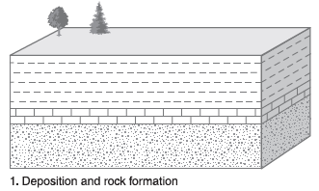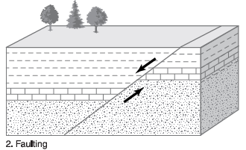

- ______________ : Layers of sedimentary rock that have been bent by crustal forces

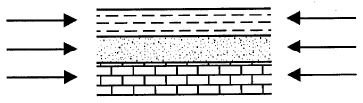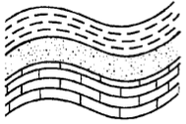

- ______________ : Formally horizontal rock layers that have been tilted at an angle by crustal activity

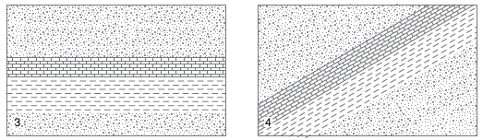
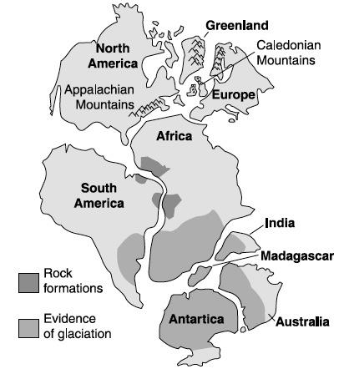
- How else do we know plates have moved?
- ______________: the continents would fit together like ______________ if they were connected.

____________: Evidence suggests that all continents were joined in one giant supercontinent 200 million years ago.

- Correlation of _______________ on different continents:
  - Similar rocks and minerals are found in _______________________ along coastal regions of different continents.

  - Similar ___________________ in North America, Greenland, and Europe.

  - Evidence of the same ____________on South America, Africa, India, Madagascar, Australia, and Antarctica.

- Most of these places are too warm for glaciers so they must have been located closer to the South Pole in the past.
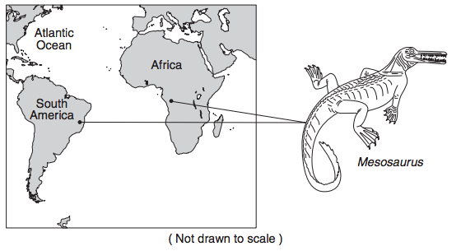
- Finding of ___________:
  - On different continents: ______________ of land animals and plants on continents far from each other.

  - In unusual locations:
    - Fossils of tropical plants are found in Antarctica and Alaska.
    - Fossils of shallow marine organisms found on the tops of mountain ranges means land has been uplifted.
    - Fossils of land animals in deep oceans means land has moved deep under water.

